Assessment Schedule – 2013

Calculus: Apply integration methods in solving problems (91579)

Evidence Statement
ONE | Expected Coverage | Achievement | Merit | Excellence
(a) | 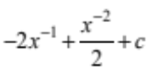 | Correct answer.
(b) | 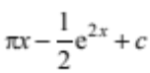 | Correct answer.
(c) | 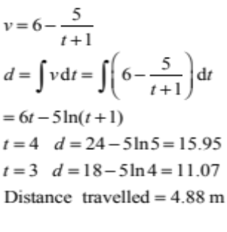 | Correct integration. | Correct answer.
(d)(i) | 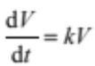
(ii) | 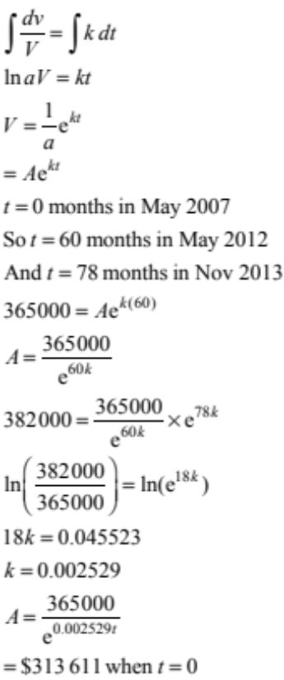 | Correct DE and integration. | Correct DE, integration and general solution to DE with logical working. | Correct answer including correct DE, integration and general solution to DE with logical working. Units not required in answer.

(e) | 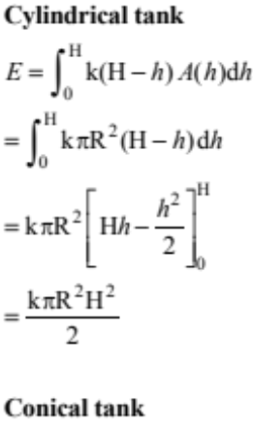  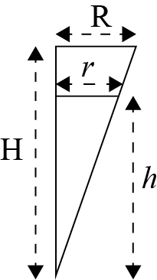-  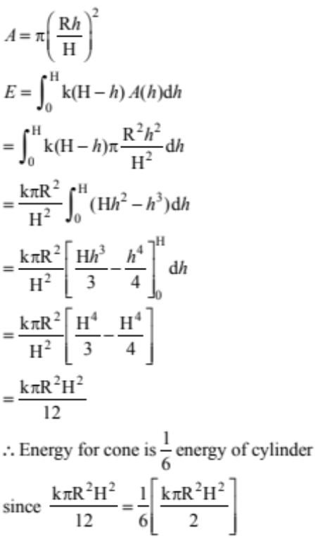 | One correct integration. | Correct energy for conical tank. | Both integrals correct and correct solution.

NØ = No response / no relevant evidence
N1 = ONE answer demonstrating limited knowledge of integration techniques
N2 = ONE correct integration
A3 = TWO of Achievement (u)
A4 = THREE of Achievement (u)
M5 = ONE of Merit (r)
M6 = TWO of Merit (r)
E7 = Excellence with minor errors ignored (t)
E8 = Excellence correct (t)

TWO | Expected Coverage | Achievement | Merit | Excellence
(a) | 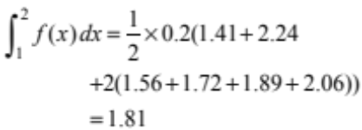 | Correct answer.
(b) | 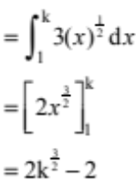 | Correct answer.
(c) | 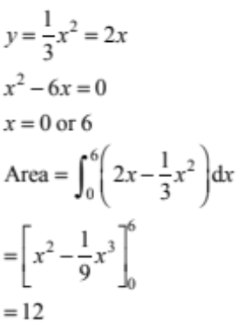 | Correct integral (or difference of two correct integrals). | Correct solution.
(d) | 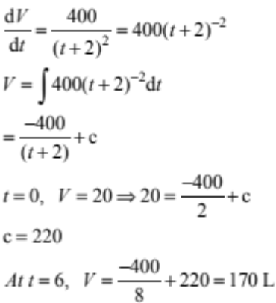 | Correct integration. | Correct solution.

(e) | 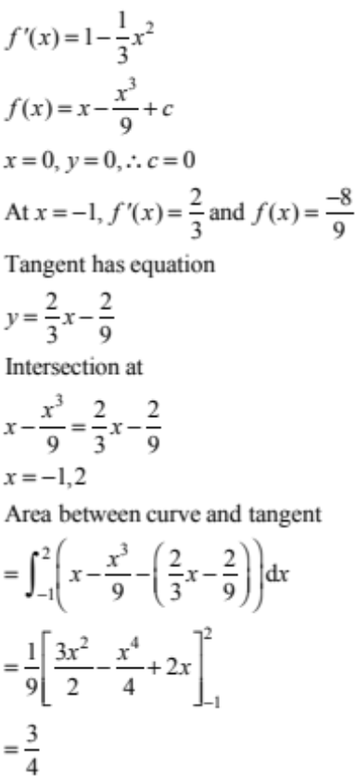 | Correct equation of tangent. | Correct expression for area required (could be difference of two integrals). | Correct solution.

NØ = No response / no relevant evidence
N1 = ONE answer demonstrating limited knowledge of integration techniques
N2 = ONE correct integration
A3 = TWO of Achievement (u)
A4 = THREE of Achievement (u)
M5 = ONE of Merit (r)
M6 = TWO of Merit (r)
E7 = Excellence with minor errors ignored (t)
E8 = Excellence correct (t)

THREE | Expected Coverage | Achievement | Merit | Excellence
(a) | 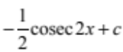 | Correct integration.
(b) | 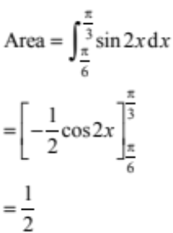 | Correct integration. | Correct answer.
(c) | 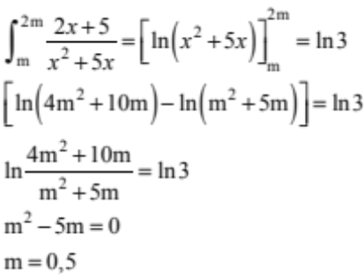 | Correct integration. | Correct answer.
(d) | 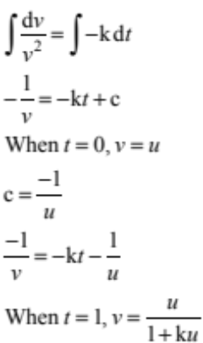 | Correct integration. | Correct solution.
(e)(i) | 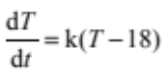
(ii) | 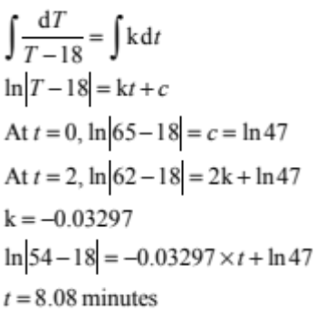 | Correct DE and integration. | Correct DE, integration and general solution to DE, with logical working and correct value of k. | Correct answer including correct DE, integration and general solution to DE with logical working. Units not required in answer.

NØ = No response / no relevant evidence
N1 = ONE answer demonstrating limited knowledge of integration techniques
N2 = ONE correct integration
A3 = TWO of Achievement (u)
A4 = THREE of Achievement (u)
M5 = ONE of Merit (r)
M6 = TWO of Merit (r)
E7 = Excellence with minor errors ignored (t)
E8 = Excellence correct (t)

Marking codes

Codes that may have been used in marking this examination paper have meaning as follows.

# Hash - where a candidate obtains a correct answer but continues with further, unnecessary, material that is incorrect but does not show that the candidate shows a lack of understanding or a contradiction.

C Consistency - where a candidate has obtained an incorrect value within a question and subsequently used that value.

NC Non-consistency - where a candidate has obtained an incorrect value or expression within a question and has not used that value or expression where it was subsequently required.

RAWW Right answer, wrong working - where a candidate presents a correct answer but the working or reasoning leading to it is incorrect, incomplete or contains one or more errors.

R Rounding error - where a candidate produces a correct sequence of calculations, but the answer does not agree to 2 significant figures with the answer given in the assessment schedule as a result of rounding a number in the sequence of calculations.

MEI Minor error ignored - where a candidate has made a minor error and this has been ignored.

Two ans Two answers given - where a candidate writes two answers, one correct and the other incorrect, and neither has been deleted (the correct answer is not accepted).

Judgement Statement
 | Not Achieved | Achievement | Achievement  with Merit | Achievement  with Excellence
Score range | 0 – 6 | 7 – 12 | 13 – 20 | 21 – 24

